The Education and Training Inspectorate

DEVELOPING SHARED EDUCATION

A FRAMEWORK FOR YOUTH PROVISION PARTNERSHIPS

March 2018

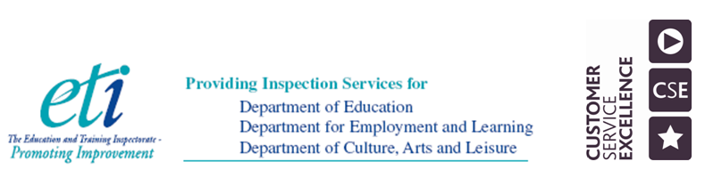
DEVELOPING SHARED EDUCATION

Introduction
Shared Education involves the provision of opportunities for children and young people from different community backgrounds to learn together for better education and reconciliation outcomes.

The vision for shared education is for:
Vibrant, self-improving shared education partnerships delivering social change through educational benefits to young people; promoting equality of opportunity, good relations, equality of identity, respect for diversity and community cohesion; and encouraging the efficient and effective use of resources.

Since the early 1980s, the Department of Education has developed and implemented a range of programmes to promote cross-community relations by bringing together young people from each of the two main traditions. The overarching aim was to improve mutual understanding and relationships between the two main traditions without excluding any other tradition. In 2011, the Department of Education launched a new Community Relations, Equality and Diversity in Education (CRED) policy which encouraged schools and youth settings to work collaboratively. In recent years, and with the support of external funding from the International Fund for Ireland and the Atlantic Philanthropies, the concept of a more strategic approach to shared education has evolved. Shared Education is now well-embedded within a wider legislative and policy context that is designed to promote equality and good relations.

The Northern Ireland Executive is seeking to create a shared society that respects diversity and has recognised the role of Shared Education in making this a reality; consequently Shared Education features in the Programme for Government. In Priorities for Youth, it is stated that Shared Education in youth work can support the Executive’s commitment to Shared Education through: “providing valuable opportunities for young people to build upon their school-based learning, to learn new skills, to develop new relationships and to develop themselves as citizens…The more opportunities children and young people have to learn and work together in a sustained and meaningful way, the more they will develop positive and inclusive attitudes towards one another.”

The Northern Ireland Executive’s commitment to creating a united, reconciled and shared society is also outlined in the Together: Building a United Community Strategy, which presents a vision for society based on equality of opportunity, the desirability of good relations and reconciliation. The strategy lays the foundation for a transformed and more shared society in the future, and Departments are working together to ensure outcomes are delivered on the ground. The strategy undertakes to “enhance the quality and extent of Shared Education provision, thus ensuring that sharing in education becomes a central part of every child’s educational experience”.

Shared Education, which aims to improve educational and reconciliation outcomes for young people, sits within a broader education policy framework designed to improve educational outcomes for young people and tackle the significant tail of educational under-achievement that has characterised our education system, by breaking the cycle of social disadvantage, educational failure and restricted life chances. The Sharing Works policy was published in September 2015 and sets out a number of policy commitments to advance Shared Education, including bringing forward legislation. The Shared Education (NI) Act 2016 provides a definition of the core minimum requirements of Shared Education. The Act places a duty on the Department of Education and the Education Authority to encourage, facilitate and promote Shared Education. The Act also provides a power to relevant arm’s length bodies, including The Youth Council NI to encourage and facilitate Shared Education. The Act sets out the purpose of Shared Education as to:
- deliver educational benefits to children and young persons;
- promote the efficient and effective use of resources,
- promote equality of opportunity, good relations and respect for identity, diversity and community cohesion.

The CRED policy, the aim of which is to contribute to improving relations between communities by educating young people to develop self-respect and respect for others, complements and underpins the Sharing Works policy in respect of the good relations, respect for identity, diversity and community cohesion aspects of Shared Education. The CRED policy also encourages formal and non-formal education providers to deliver in a way that provides opportunities for young people to build relationships with those of different background and traditions. Shared Education provides a further opportunity to do so, whilst also seeking to improve educational outcomes.

The Case for Shared Education
The case for Shared Education has now been well established. This may be summarised as:
- The education case – improving access for young people to a wider choice of subjects encompassing the full range of the curriculum; increasing access to specialist teaching and to modern facilities; and facilitating the sharing of ideas and good practice between education providers.
- The social case – improving societal well-being by promoting a culture of mutual understanding and inter-relationship through significant, purposeful and regular engagement and interaction in learning between young people from different community backgrounds.
- The economic case – making more effective and efficient use of limited resources to improve value for money.

The Framework
The following framework provides youth setting partnerships with the means of self-evaluating the extent and quality of their shared education provision and to set targets for development. Youth settings are at different starting points and stages of development along this continuum in regard to their shared education journey. For some they are beginning their journey and for others, they are developing further and even embedding high quality shared education. The ETI will work alongside youth settings in supporting the development of shared education through honest and robust self-evaluation, recognising the time, resources and strategic planning needed to progress shared education effectively. A key feature of using the framework is that each partnership identifies the progress made in demonstrating measurable educational outcomes and delivering social change by achieving conditions whereby young people demonstrate positive attitudes, dispositions, behaviours, understanding of reconciliation and respect for others.

Self-evaluation: Mapping our journey to effective shared education

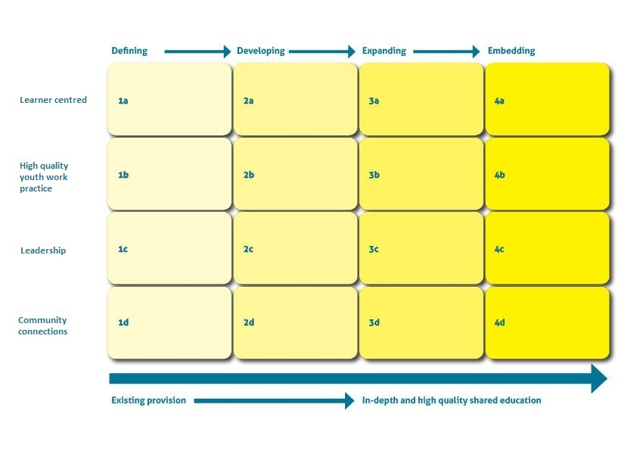

Learner centred | Defining 1a  Youth settings identify the need to: | Developing 2a  Youth partnerships collaborate to: | Expanding 3a  Youth partnerships collaborate to: | Embedding 4a  Youth partnerships collaborate to:
Participation in shared education | discuss with the young people in their own youth setting their views on engaging with young people from a different youth setting, preparing them for their participation in shared youth programmes | - engage the young people and youth workers from the different youth settings in jointly agreeing and planning shared youth programmes | - support the young people to develop, review and improve their shared youth programmes | - empower the young people to initiate, develop, manage and embed their shared youth programmes in a planned, connected and progressive way with agreed outcomes
Surmounting barriers  e.g. cognitive, emotional, personal and social | - discuss and agree with the young people their assessed needs for engaging in shared education | - design and develop shared youth programmes which challenge, develop and extend the young people’s knowledge and understanding of issues which affect them and their community | - review with the young people how the shared youth programmes are meeting their needs and contributing to their personal and social development | - enable the young people to overcome confidently any barriers to participating in shared youth programmes and to have the young people actively engaged in meeting their own needs as well as the needs of others
Outcomes  Education and reconciliation | - define and negotiate with the young people their anticipated learning outcomes in relation to their personal and social development; in particular, their knowledge and understanding of how inclusive and accepting they are of others | - develop the young people’s knowledge, understanding and social skills through working collaboratively in a shared learning environment | - demonstrate the on-going progress of the young people in their learning and their acquisition of positive attitudes and dispositions, through their participation in shared youth programmes | - improve the outcomes the young people achieve and demonstrate through effective self-evaluation that they have developed personal and social skills to progress their understanding of themselves, their peers, others and their community

High quality youth work practice | Defining 1b  Youth settings identify the need to: | Developing 2b  Youth partnerships collaborate to: | Expanding 3b  Youth partnerships collaborate to: | Embedding 4b  Youth partnerships collaborate to:
Planning for shared education | - identify and develop initial contact with another youth project/s from a different community background and commence planning for joint programmes | - plan and commence a joint shared youth programme in collaboration with the young people and connect this planning to other aspects of the provision | - monitor and review regularly with the young people the effectiveness of the programme planned and how it is improving their anticipated learning outcomes | - involve young people and youth workers fully in the planning, self-evaluation and continuous improvement of shared youth programmes
Quality of learning experiences | - engage the young people in preparatory work in their own youth settings and then introduce them through appropriate activities to young people from other traditions | - engage the young people in interesting, challenging and purposeful programmes, where they discuss inclusion, difference and controversial issues relevant to their needs and context | - expand the programmes across the age groups and continue to build the capacity of staff to improve the young people’s skills, knowledge and understanding of others | - embed best practice through inclusive youth settings, where all of the staff and the young people demonstrate a culture of acceptance, integration and respect
Assessment for, and of, shared education | - develop a system of self-evaluation to enable young people to baseline and assess their skills, knowledge and understanding of others | - support the young people to commence the critical reflection and assessment of their progress against their anticipated learning outcomes | - monitor and evaluate the impact of shared youth programmes on the educational and reconciliation outcomes of the young people | - demonstrate that the self-evaluation processes used by the staff and the young people are embedded and informing improvement

Effective Leadership | Defining 1c  Youth leaders identify the need to: | Developing 2c  Youth partnerships collaborate to: | Expanding 3c  Youth partnerships collaborate to: | Embedding 4c  Youth partnerships collaborate to:
Strategic leadership for shared education | - explore and agree among partners an understanding of one another’s context, the opportunities for shared youth education, and the potential impact on the young people | - agree a clear vision for shared education and have a coherent development plan for managing the partnership going forward | - involve all of the young people, staff and management in expanding shared education into governance, curriculum planning, and youth work practice | - establish and sustain effective leadership for the shared education programme so that it is embedded into joint planning and collaborative working
Action to promote improvement in shared education | - engage with staff and young people to define and decide on what shared youth programmes are to be included in annual development plans | - conduct annually an assessment of the impact of shared youth programmes on the outcomes for the young people | - involve all partners in a combined evaluation of the effectiveness of shared youth programmes and through this evaluation inform and affect improvement | - demonstrate how the action taken to improve the shared youth programmes have continued to progressively meet and benefit the needs of the young people and their communities
Empowering and supporting staff in shared education | - facilitate staff to identify their needs for Continuing Professional Development in shared youth education | - access and provide shared youth education training for all staff, continuing to build their capacity to deliver shared education programmes | - enable and empower staff across the partnership to consistently expand their work and disseminate effective practice in shared education to others | - have in place experienced and highly skilled staff, who have the capacity to continuously and confidently affect improvements in the provision and in the outcomes for the young people
Resources/  Accommodation | - audit how resources and accommodation can be used and shared with other youth settings | - share resources and accommodation between youth settings and their communities | - assess the efficiency of shared resources and accommodation and the impact on learning outcomes and value for money | - use effectively resources and accommodation between youth settings and their communities to establish shared youth education as common practice

Community Connections | Defining 1d  Youth settings leaders identify the need to | Developing 2d  Youth partnerships collaborate to: | Expanding 3d  Youth partnerships collaborate to: | Embedding 4d  Youth partnerships collaborate to:
Parents/ Carers | - consult with parents/carers in the planning for shared youth education activities | - inform parents/carers of the emerging benefits of shared youth education and seek their views to inform improvement | - develop a programme of shared youth programmes, which involves and engages parents/carers | - sustain programmes of shared education programmes which have high levels of engagement from parents/carers
External partners | - assess support needs and identify key external partners to support the development of shared youth programmes | - engage with an appropriate range of external partners to develop shared education programmes, which are agreed as beneficial for the young people and their communities | - evaluate with external partners the impact of shared youth collaborative practice on the young people and identify the benefits of this work on the local community | - have in place an effective network of external partners which supports the youth work staff and young people in the delivery of shared education programmes
Community access and engagement | - raise the awareness of the local community about the benefits of shared youth programmes and identify and prepare for potential community issues | - develop an understanding and acceptance within communities about the value, purpose and positive impact of shared youth programmes | - work with the young people to disseminate and promote their shared youth programmes across their own community and that of their partner organisation | - have shared youth programmes accepted as common practice and valued as an integral part of youth provision for the young people, their families and their communities

Self-evaluation: Mapping our journey to effective shared education
 | Defining | Developing | Expanding | Embedding
Learner centred
High quality youth work practice
Leadership
Community connections

Main forms of evidence to support evaluations

Going well (max 3)
1.

2.

3.

Going forward (max 3)
1.

2.

3.

Overall evaluation
1.

2.

3.

Youth providers should seek to engage in self-evaluation as a partnership at the outset, in order to plan collaboratively joint actions to bring about improvement.

