

**Remote Learning to support pupils with special educational needs**

* Last week, schools across Northern Ireland have set up an online support community on Twitter last week which can be accessed @learn_ni School principals and teachers are adding daily a range of resources, links and ideas to support each other with remote learning.
* It is imperative for schools to ensure that all children have their C2K username and password in order to access C2K software from home. It would be helpful to remind children of the SMART rules when using the internet.
* Children thrive when there is a plan for the day or a daily schedule. It helps them to feel safe and secure. It is also very important that there is a **balance** between online learning, written and practical activities, outdoor learning and free time.
* Symbols can help explain what’s happening now and next.

[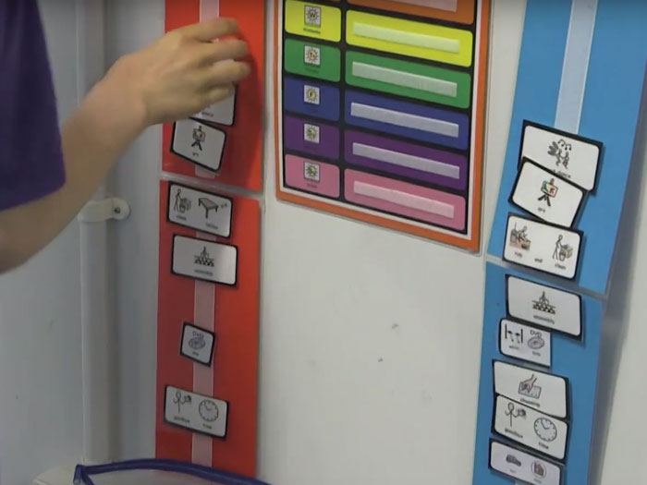](https://www.widgit.com/images/symbols/uses/large/timetable.jpg)

* In schools visual timetables help children to understand routines throughout the school day, reducing anxiety and improving learning and behaviour.
* Here are some symbols you could use to create a timetable for home.

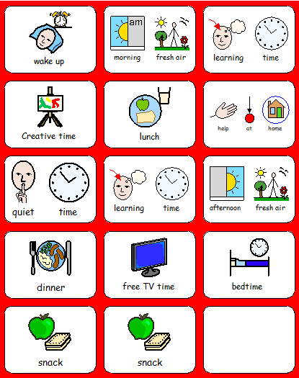

**The Middletown Centre for Autism has some very helpful resources and on-line learning for parents.**

<https://www.middletownautism.com/>

Clicking on the ‘Online Learning’ link takes users to <https://vle.middletownautism.com/>

Registration is required to access all of the online learning; upcoming webinars are available for booking on Middletown’s Facebook and Twitter pages.

A wide range of Covid-specific resources from Middletown Centre for Autism are available. These include social stories, games, stories, visual supports and resources from a wide variety of sources for children, young people, parents and carers. ‘

<https://www.middletownautism.com/covid19>

**Useful websites for parents kindly suggested by Anne Moore, principal of Glenveagh Special School**

<http://therapystreetforkids.com/>

|  |  |
| --- | --- |
|  | [Therapy Street for Kids | Occupational Therapy](http://therapystreetforkids.com/)  A resource for parents who are looking for occupational therapy activities that can be done at home and with household materials. Skill areas include fine motor, visual motor, crossing midline, self help skills, sensory processing and handwriting.  therapystreetforkids.com |

Sensory activities

[www.childhood101.com/sensory-play-ideas](http://www.childhood101.com/sensory-play-ideas)

[www.handsonaswegrow.com/sensory-activities-for-kids](http://www.handsonaswegrow.com/sensory-activities-for-kids)

[www.sensorydispensary.blogspot.com/2017/09/story-massage.html](http://www.sensorydispensary.blogspot.com/2017/09/story-massage.html)

<http://www.fiveacrewood.co.uk/wp-content/uploads/2014/02/iPad-apps21.pdf>  sensory apps

Literacy and numeracy

<https://www.youtube.com/channel/UCvsTtaCSauYyCf-Y77qlRgA> attention autism videos

[www.ccea.org.uk/learning-resources/science-through-stories-sen](http://www.ccea.org.uk/learning-resources/science-through-stories-sen)  literacy

<https://ccea.org.uk/downloads/docs/ccea-asset/Resource/Responding%20Responsibly%3A%20Money%20Matters.pdf> money

Home Economics

<http://www.cookeryonline.com/Resource/Kitchen%20Health%20&%20Safety.htm>

<http://www.kidsandcooking.co.uk/teachingkidsfoodhygiene.html>

<https://www.healthykids.nsw.gov.au/recipes/food-safety-and-hygiene.aspx>

<https://www.pinterest.co.uk/chloe12345/life-skills-visual-recipes>

Early development on-screen learning suggestions:

* Getting Ready to Learn Book Bags.
* Getting Ready to Learn Happy Healthy Kids physical equipment.
* Outdoor physical activities.
* Look at the wildlife, hedgerows and keep track of the changes in nature and photos and drawings.
* Gardening activities- planting and digging.
* Make models from junk materials, Duplo, Lego (*see some suggestions for Lego below- note American spelling*).
* Cut and stick activities, paint and draw.
* Fill a sink with water and engage in water play.
* Play board games e.g. snap, Dobble.
* Bedtime box *Suggested contents:* Teddy in box decorated as a bed; Blanket; Small toy for teddy; CD of bedtime songs and rhymes; Storybook – *Five Minutes Peace, Goodnight Moon, The Gruffalo, Goodnight, Little Bear.*
* Happy sack/books *Suggested contents:* A selection of photographs of happy people/faces (or a variety of expressions for comparison/discussion); CD of happy songs and rhymes; Storybook – *I Feel Happy* ; Use phone to record happy sounds, laughing etc.
* New baby box *Suggested contents:* A baby doll; Box decorated as cot/cradle with blanket; Bottle, clothing and nappies; Storybook – *You’re the Biggest* (brilliant for new big brothers and sisters!

**Recipe for playdough**

2 cups of plain flour

2 tablespoons of vegetable oil

½ cup of salt

2 tablespoons of cream of tartar

1 cup of water and food colouring, if desired.

* Playdough bag/box *Suggested contents:* Recipe card so children can easily make it with some help (see recipe); shape cutters egg cups, plastic glasses and natural materials around the home and garden; range of tools for shaping and creating marks, using cooking utensils; special ingredients e.g. rice, glitter, spices and herbs.
* Bake and cook with adults.
* Ideas to promote fine motor skills include scissor activities with dough, newspaper, old magazines and card.  As the skills progress change the thickness of the paper to make it more difficult and challenging by using former birthday cards and Christmas cards. Use household items like tongs and tweezers to lift sticks, cotton balls, small stones, etc.
* Don’t forget the gross motor skills.  Apart from the normal running and outdoor play, indoor activities could include: encourage children to bear walk, roll along the floor with arms tucked in and stretched out to strengthen core muscles, balancing/following on the lines on the tiles and using them to hopscotch and not forgetting to encourage using alternate feet on the stairs while counting.
* Further ideas on app called *50 Things To Do Before You are Five* which is available on Google Play on the App Store.
* Create a routine for the day using pictures/drawings/words.
* Learn to ride a bike, bat/ball activities, skip, run, dig, hop.
* Take a walk and look at the wildlife, hedgerows and keep track of the changes in nature and record findings in photos and drawings.
* Gardening activities- planting and digging.
* Keep a dairy/journal.
* Make models from junk materials, Duplo, Lego (*see some suggestions for Lego below- note American spelling and some grammatical errors*!).
* Play board games e.g. dominoes.
* Read a book.
* Practise your musical instrument e.g. recorder, piano, violin flute etc.
* Dance or enjoy some yoga stretches.
* Paint, draw or make a model from junk materials.
* Play board games such as Monopoly or Trivial Pursuit.
* Play card games such as Uno or Phase 10.
* Bake or cook.
* Go out into your garden and enjoy the fresh air- run, jump, skip, kick a ball, play tennis up against a wall.

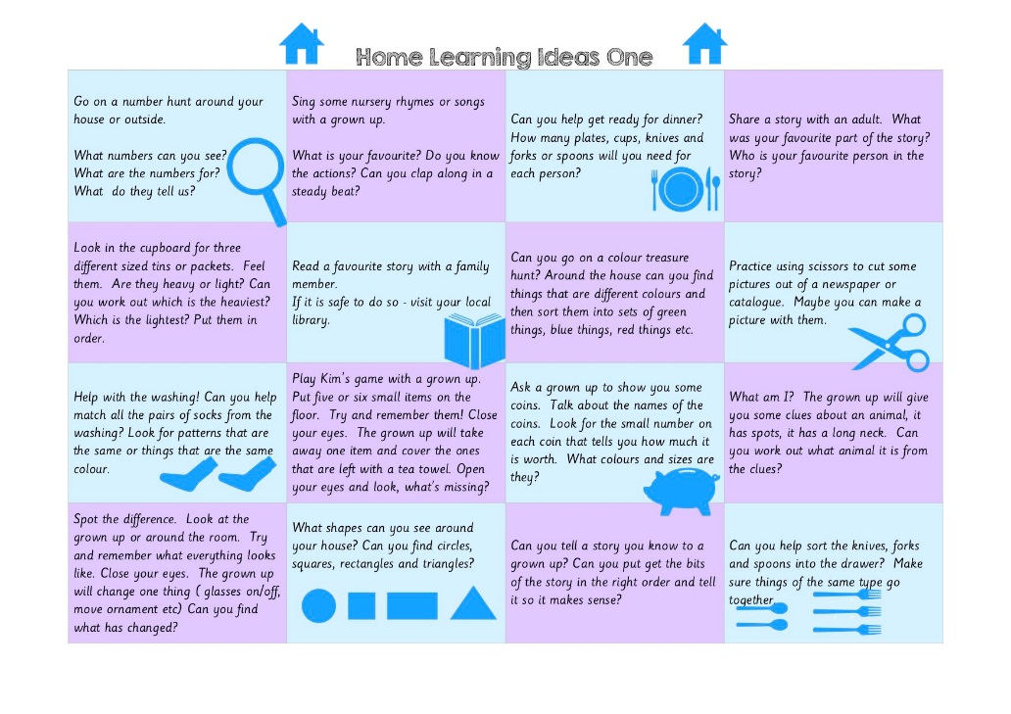Further home learning ideas kindly supplied below by Pamela Algie, principal of Bangor Nursery School.

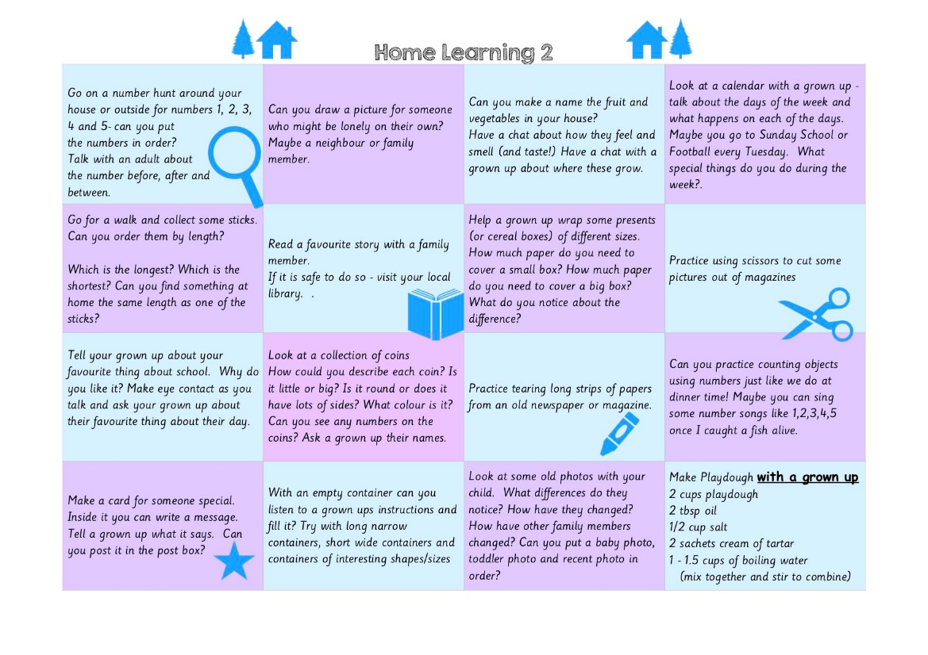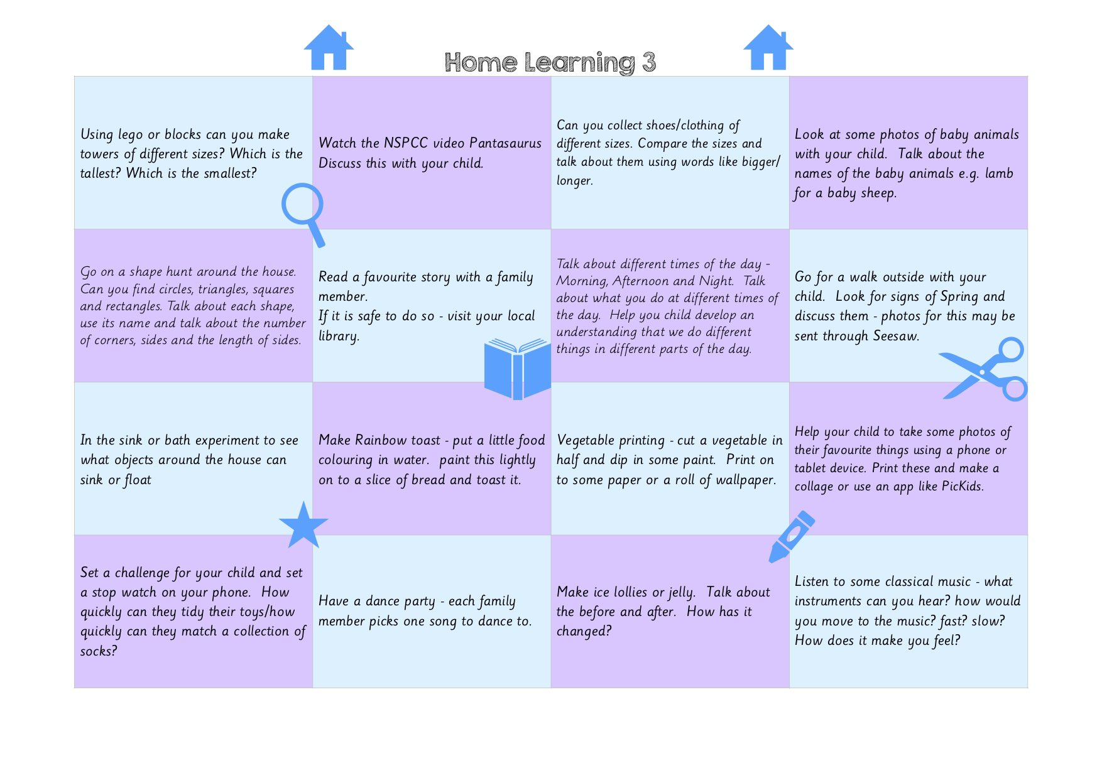

**Screen learning suggestions, kindly supplied by James Curran, principal of Harberton Special School:**

Rainbow

Match it up 3

Baby images

Phones for kids

Toy story

Elmo's 123

Paint Sparkle

Touch Emotions

Memory 4-7

Hungry Caterpillar Counting

Shape puzzle

Elmo’s 123

Critter’s Maths

ABC Wildlife Letters

Maths 3-4

Montessori Intro to Letters

HairyLetters

Elmo’s ABC

Maths 4-5

Park Maths

ChooseIT Literacy

ChooseIT Numeracy

ChooseIT Science

Spellosaur

Amazing Time

Addition & Subtraction for Kids

iMovie

PuppetPals

Dexteria Junior

Maths 6-7

Phonics Master

Spelling Magic

Amazing Coin

Addition Wiz

Subtraction Wiz

Math Bingo

Rainbow Sentences

Explain Everything

Dyslexia Quest

Math Bingo

Treasure Hunt

Dyslexia Quest

Memory Block

Speak it

Letter tracking

Brain School

Dyslexia Quest

Memory Block

Speak it

Letter tracking

Brain School

**Children’s websites**

 

**Kids' Zone**

|  |  |
| --- | --- |
| [KS2 BBC Bitesize Revision](http://www.bbc.co.uk/schools/ks2bitesize/) | [KS1 BBC Bitesize Revision](http://www.bbc.co.uk/schools/ks1bitesize/) |
| [BBC Schools](http://www.bbc.co.uk/schools/) | [CITV](http://www.citv.co.uk/) |

